Module Name: Login
Test Case ID: SD_TC_001
Webpage URL: https://www.saucedemo.com/

● Scenario ID: 1a
Scenario: Sign up with valid credentials
Test Steps:
1. Open SauceDemo
2. Enter valid username & password
3. Click Login

Screenshots:
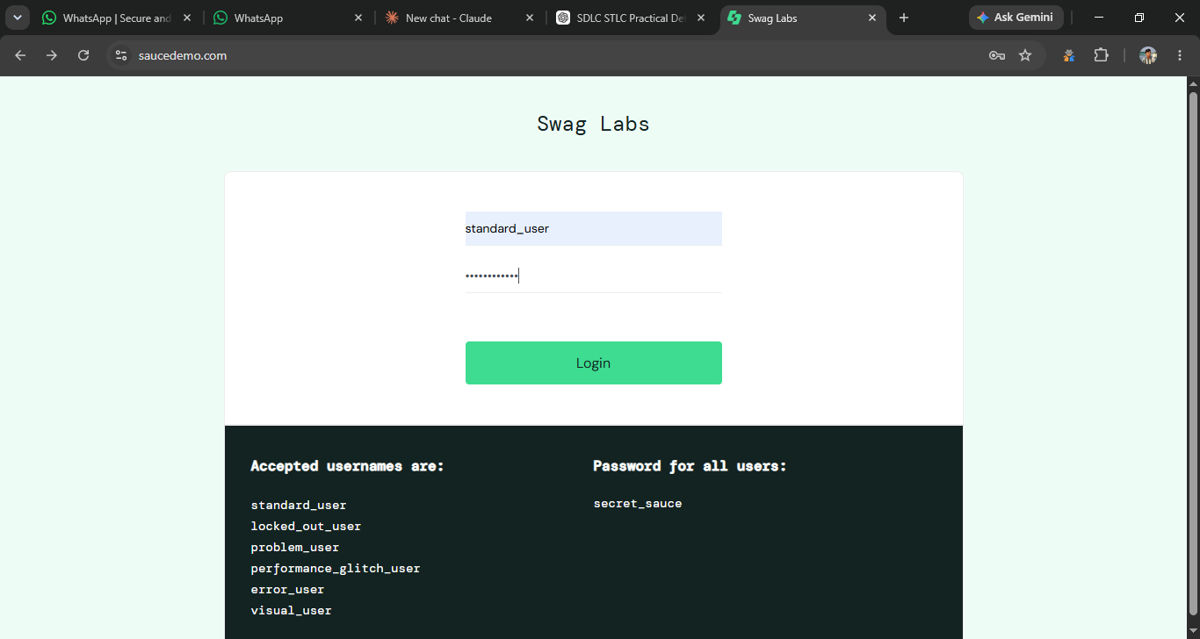

● Scenario ID: 1b
Scenario: Login with invalid password
Test Steps:

1.Enter wrong password
2.click Login

Screenshots:
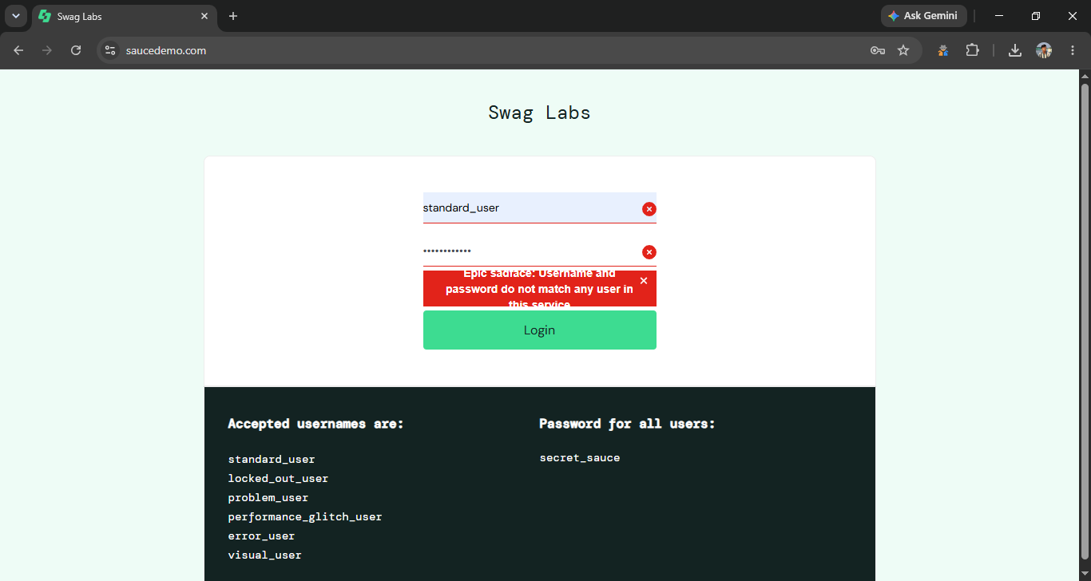

● Scenario ID: 1c
Scenario: Login with empty fields
Test Steps:
1.Leave Username blank
2. click Login
Screenshots:
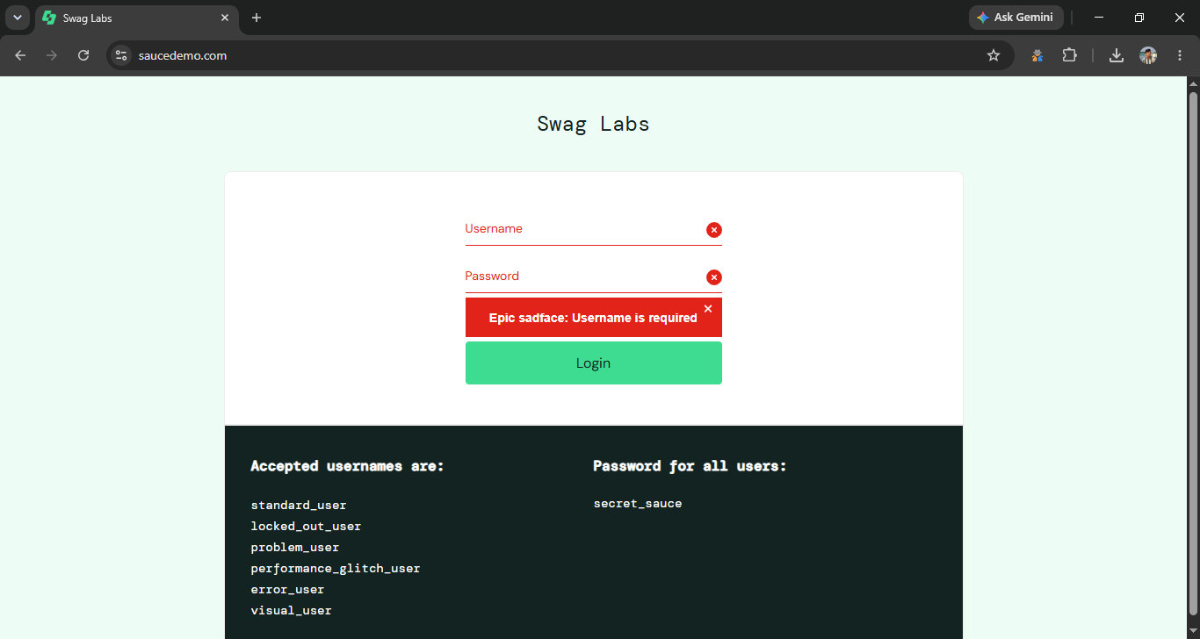

● Scenario ID: 2a
Scenario: Verify Inventory Page
Test Steps:
Login successfully
Screenshots:
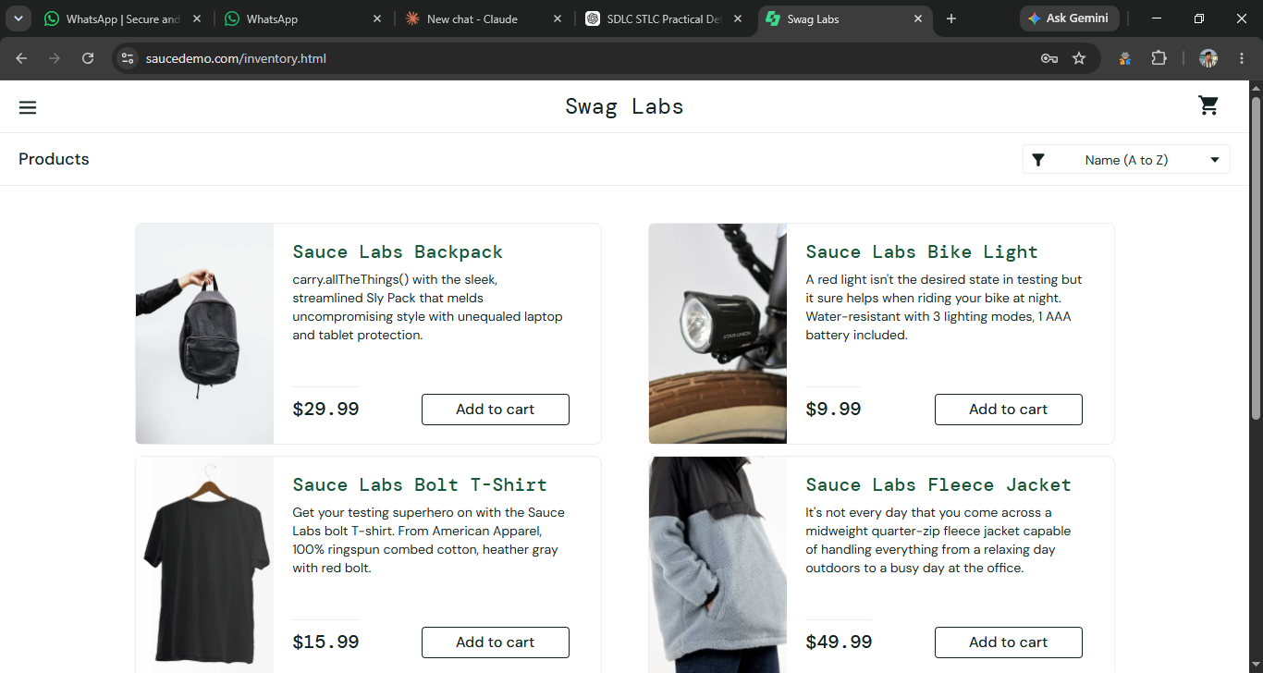

● Scenario ID: 2b
Scenario: Add Backpack to Cart
Test Steps:
Click Add to Cart
Screenshots:


● Scenario ID: 2c
Scenario: Remove Product
Test Steps:
Click Remove
Screenshots:
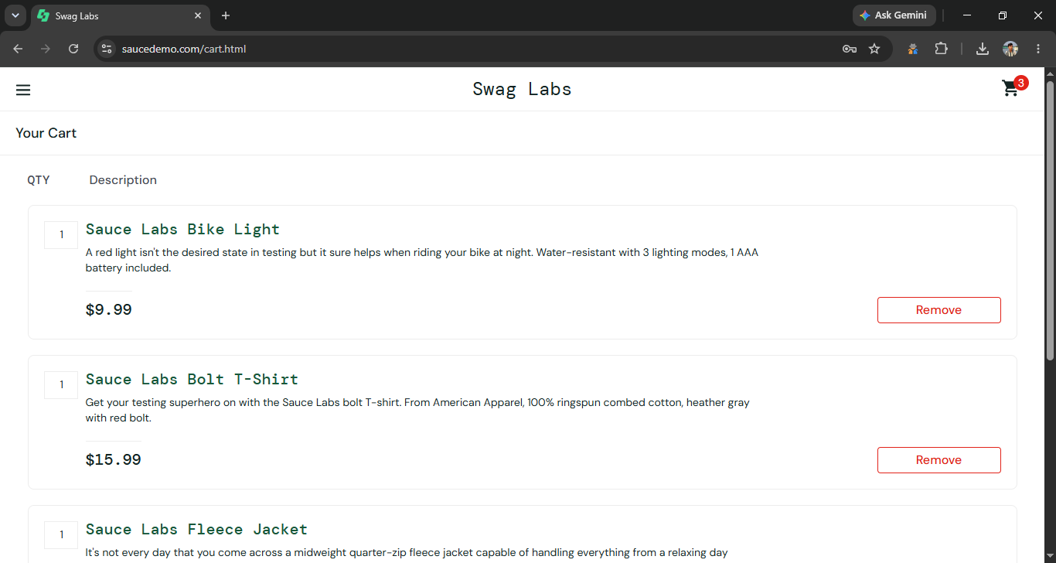

● Scenario ID: 3a
Scenario: Open Shopping Cart
Test Steps:
Click Cart icon
Screenshots:


● Scenario ID: 3b
Scenario: Verify Product in Cart
Test Steps:
Check cart contents
Screenshots:


● Scenario ID: 4a
Scenario: Checkout with valid details
Test Steps:
Click Checkout → Enter details → Continue
Screenshots:
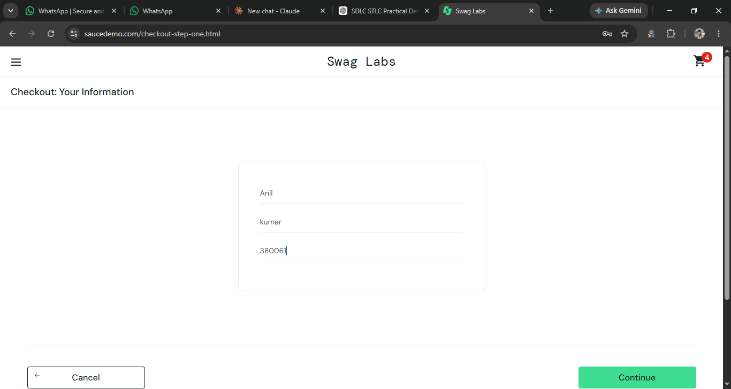

● Scenario ID: 5a
Scenario: Complete Order
Test Steps:
Click Finish
Screenshots:
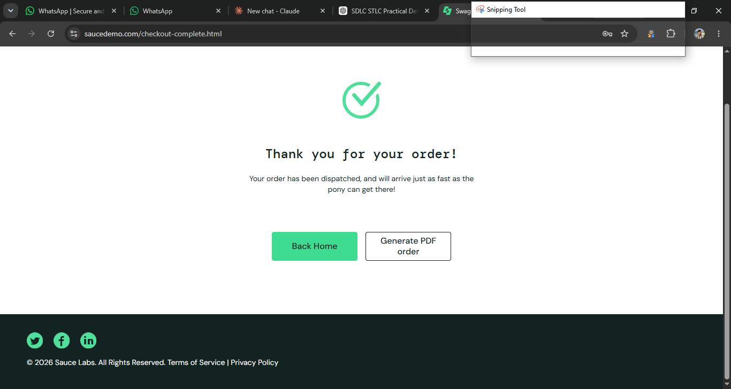

● Scenario ID: 6a
Scenario: Logout
Test Steps:
Menu → Logout
Screenshots:
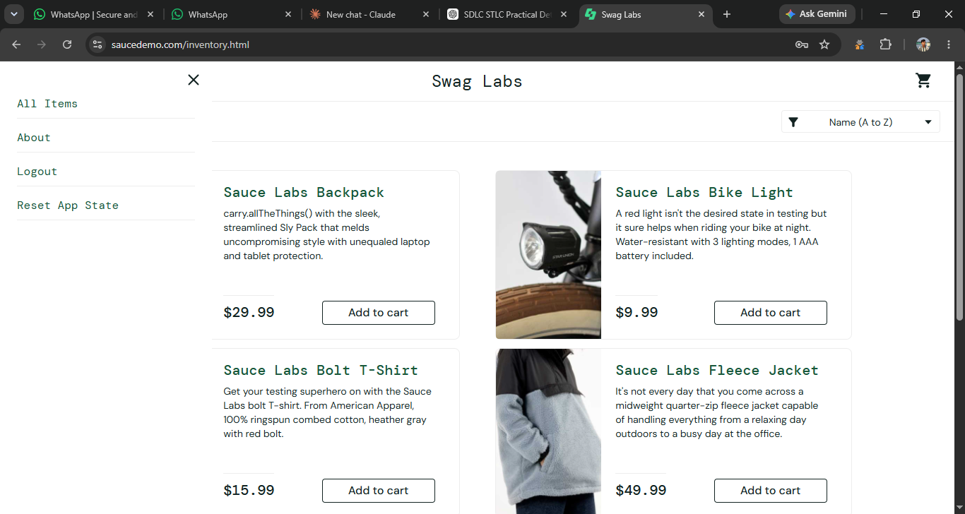

● Scenario ID: 7a
Scenario: Check Responsive Layout
Test Steps:
Resize browser window
Screenshots:
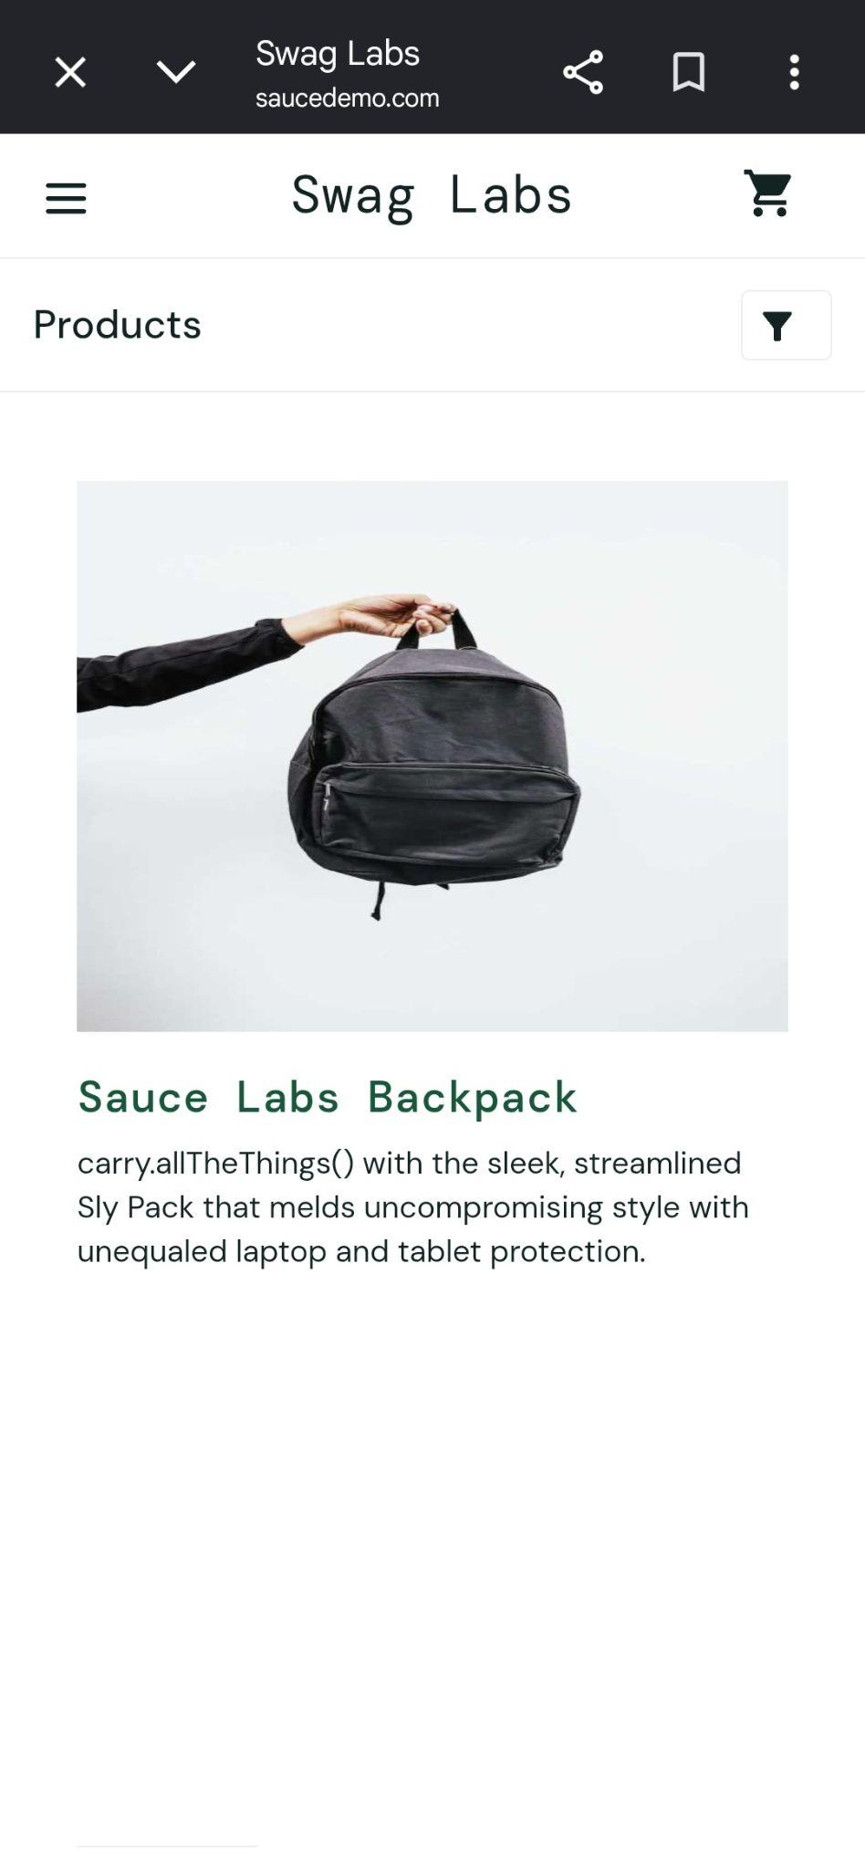
● Summary Of Test Results:

Total Test Cases- 15
Passed- 14
Failed- 1
Pass %- 93.33%

● Conclusion and Recommendations:
Pass Rate: 93.33%, Application Performs Well with Minor Improvements Required

● Issues Found
1. Product Not Displayed in Shopping Cart (3b)
After adding a product to the cart and opening the Shopping Cart page, the selected product was not displayed as expected.
2. Checkout Validation Issue (4b)
When the First Name field was left empty during checkout, the expected validation message was not displayed correctly.

● Recommendations
1. Improve Cart Synchronization
Ensure that products added to the cart are correctly synchronized and displayed on the Shopping Cart page.
2. Strengthen Checkout Validation
Validate all mandatory checkout fields and display clear error messages before allowing the user to continue.

.

